Temperature and Humidity Sensor (DHT11)   
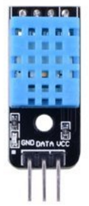

Overview

The DHT11 module combines a capacitive humidity sensor and an NTC thermistor to measure ambient air humidity and temperature, with high reliability and excellent long-term stability. An onboard microcontroller allows it to outputs to a single digital pin, so no analog-to-digital conversion required. This experiment shows how to query the DHT11’s sensor readings and display them through the Raspberry Pi’s command line interface.

The Experimental Materials

Raspberry Pi x1

Breadboard x1

DHT11 module x1

Dupont jumper wires

Experimental Procedure

1. If you have not done so already, prepare your development system by installing the Python interpreter, RPi.GIO library, and wiringPi library as described in READ_ME.TXT.
2. Install the DHT11 temperature and humidity sensor on your breadboard, and use Dupont jumper wires to connect it to your Raspberry Pi as illustrated in the Wiring Diagram below.
3. Execute the sample code stored in this experiment’s subfolder.

If using C, compile and execute the C code:  
cd Code/C  
gcc dht11.c -o dht11.out –lwiringPi  
./dht11.out

If using Python, launch the Python script:  
cd Code/Python  
python dht11.py

1. Make experimental observations. The temperature and relative humidity readings are displayed on the Raspberry Pi command line interface and repeatedly updated. For more details on communicating with the DHT11 from software, search the internet for “DHT11 datasheet.”

Wiring Diagram

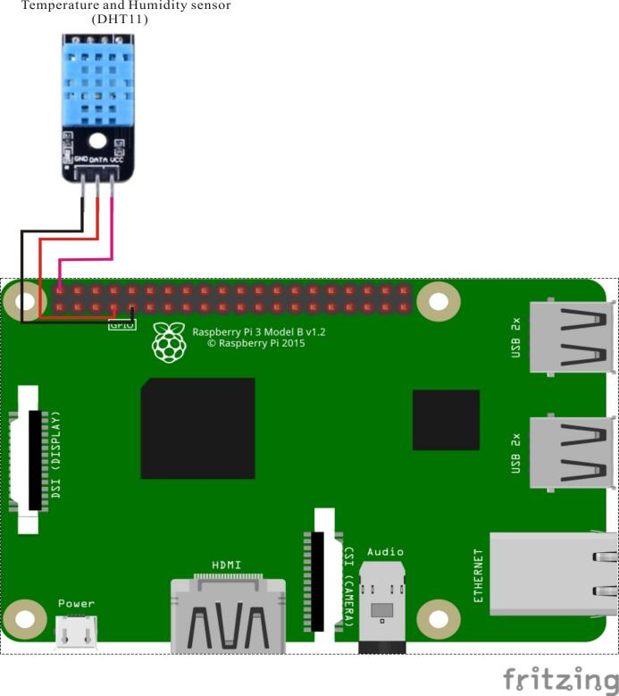

Temperature & Humidity Sensor (DHT11) pin position:

DATA ↔ Raspberry Pi pin 7

VCC ↔ Raspberry Pi +5V

GND ↔ Raspberry Pi GND

Sample Code

Python Code

#!/usr/bin/python

import RPi.GPIO as GPIO

import time

channel = 7

data = []

j = 0

humidity = 0

temperature = 0

check = 0

tmp = 0

GPIO.setmode(GPIO.BOARD)

def readSensorData():

global data, j

time.sleep(1)

GPIO.setup(channel, GPIO.OUT)

GPIO.output(channel, GPIO.LOW)

time.sleep(0.02)

GPIO.output(channel, GPIO.HIGH)

GPIO.setup(channel, GPIO.IN)

while GPIO.input(channel) == GPIO.LOW:

continue

while GPIO.input(channel) == GPIO.HIGH:

continue

while j < 40:

k = 0

while GPIO.input(channel) == GPIO.LOW:

continue

while GPIO.input(channel) == GPIO.HIGH:

k += 1

if k > 100:

break

if k < 8:

data.append(0)

else:

data.append(1)

j += 1

print "sensor is working."

print data

def crc():

global temperature, humidity, check, tmp

humidity_bit = data[0:8]

humidity_point_bit = data[8:16]

temperature_bit = data[16:24]

temperature_point_bit = data[24:32]

check_bit = data[32:40]

humidity = 0

humidity_point = 0

temperature = 0

temperature_point = 0

check = 0

for i in range(8):

humidity += humidity_bit[i] * 2 ** (7 - i)

humidity_point += humidity_point_bit[i] * 2 ** (7 - i)

temperature += temperature_bit[i] * 2 ** (7 - i)

temperature_point += temperature_point_bit[i] * 2 ** (7 - i)

check += check_bit[i] * 2 ** (7 - i)

tmp = humidity + humidity_point + temperature + temperature_point

if check == tmp:

return 1

else:

return 0

def loop():

readSensorData()

if crc():

print "temperature : ", temperature, ", humidity : " , humidity

else:

print "wrong"

print "temperature : ", temperature, ", humidity : " , humidity, " check : ", check, " tmp : ", tmp

if __name__ == '__main__':

try:

loop()

except KeyboardInterrupt:

GPIO.cleanup()

C Code

#include <wiringPi.h>

#include <stdio.h>

#include <stdlib.h>

typedef unsigned char uint8;

typedef unsigned int uint16;

typedef unsigned long uint32;

#define HIGH_TIME 32

int pinNumber = 7;

uint32 databuf;

uint8 readSensorData(void)

{

uint8 crc;

uint8 i;

pinMode(pinNumber, OUTPUT); // set mode to output

digitalWrite(pinNumber, 0); // output a high level

delay(25);

digitalWrite(pinNumber, 1); // output a low level

pinMode(pinNumber, INPUT); // set mode to input

pullUpDnControl(pinNumber, PUD_UP);

delayMicroseconds(27);

if(digitalRead(pinNumber) == 0) //SENSOR ANS

{

while(!digitalRead(pinNumber)); //wait to high

for(i=0;i<32;i++)

{

while(digitalRead(pinNumber)); //data clock start

while(!digitalRead(pinNumber)); //data start

delayMicroseconds(HIGH_TIME);

databuf*=2;

if(digitalRead(pinNumber)==1) //1

{

databuf++;

}

}

for(i=0;i<8;i++)

{

while(digitalRead(pinNumber)); //data clock start

while(!digitalRead(pinNumber)); //data start

delayMicroseconds(HIGH_TIME);

crc*=2;

if(digitalRead(pinNumber)==1) //1

{

crc++;

}

}

return 1;

}

else

{

return 0;

}

}

int main (void)

{

if (-1 == wiringPiSetup())

{

printf("Setup wiringPi failed!");

return -1;

}

pinMode(pinNumber, OUTPUT); // set mode to output

digitalWrite(pinNumber, 1); // output a high level

while(1)

{

pinMode(pinNumber,OUTPUT); // set mode to output

digitalWrite(pinNumber, 1); // output a high level

delay(3000);

if(readSensorData())

{

printf("Congratulations ! Sensor data read ok!\n");

printf("RH:%d.%d%\n",(databuf>>24)&0xff,(databuf>>16)&0xff);

printf("TMP:%d.%dC\n",(databuf>>8)&0xff,databuf&0xff);

databuf = 0;

}

else

{

printf("Sorry! Sensor does not respond!\n");

databuf = 0;

}

}

return 0;

}

Technical Background

**◆** Working voltage: 5VDC/3.3VDC.

**◆** Humidity measurement range: 20%~90%RH.

**◆** Measurement accuracy: ±5%RH.

**◆** Temperature measurement range: 0 ~ 50 ℃

**◆** Temperature measuring accuracy: ±2 ℃

**◆** Data port equipped with a pull resistor

**◆** 3mm fixed screw hole for easy installation